ish¿u ysñlï weúßKs $ All Rights Reserved

St. Peter's College

St. Peter's College

St. Peter's College

புனித பேதுரு கல்லூரி

புனித பேதுரு கல்லூரி

புனித பேதுரு கல்லூரி

புனித பேதுரு கல்லூரி

புனித பேதுரு கல்லூரி

புனித பேதுரு கல்லூரி

புனித பேதுரு கல்லூரி

புனித பேதுரு கல்லூரி

Ydka; mS;r úÿy,

Ydka; mS;r úÿy,

Ydka; mS;r úÿy,

Ydka; mS;r úÿy,

Ydka; mS;r úÿy,

Ydka; mS;r úÿy,

Ydka; mS;r úÿy,

Ydka; mS;r úÿy,

Ydka; mS;r úÿy,

Ydka; mS;r úÿy,

St. Peter's College

St. Peter's College

St. Peter's College

St. Peter's College

St. Peter's College

St. Peter's College

St. Peter's College

St. Peter's College

St. Peter's College

St. Peter's College

புனித பேதுரு கல்லூரி

புனித பேதுரு கல்லூரி

புனித பேதுரு கல்லூரி

புனித பேதுரு கல்லூரி

புனித பேதுரு கல்லூரி

புனித பேதுரு கல்லூரி

புனித பேதுரு கல்லூரி

புனித பேதுரு கல்லூரி

Ydka; mS;r úÿy,

Ydka; mS;r úÿy,

Ydka; mS;r úÿy,

Ydka; mS;r úÿy,

Ydka; mS;r úÿy,

Ydka; mS;r úÿy,

Ydka; mS;r úÿy,

Ydka; mS;r úÿy,

Ydka; mS;r úÿy,

Ydka; mS;r úÿy,

St. Peter's College

St. Peter's College

St. Peter's College

St. Peter's College

St. Peter's College

St. Peter's College

St. Peter's College

E

I,II

**bx.%Sis**

**English Language**

**meh**

**Hours**

**08 fY%aKsh – f;jk jdr we.hsu - 2022**

**தரம் 08 - ஆண்டிறுதி மதிப்பீடு - 2022**

***Grade 08 – Third TermExamination - 2022***

Ydka; mS;r úÿy, - fld<U 04

புனித பேதுரு கல்லூரி, கொழும்பு 4

***St. Peter's College - Colombo 04***



01. Fill in the blanks by using the correct vowels (a, e, i, o, u). ***(05 Marks)***

1. Comm___ttee 6. Envir___nment

2. Disc___ssion 7. Phot___graph

3. D___signed 8. Orn____thologist

4. Lang___age 9. Migr____nt

5. Exper___ence 10. Aggr____ssive

01. Arrange the given words and make meaningful sentences. ***First one is done for you.*** ***(05 Marks)***

1. Along / the / We / road / walked

***We walked along the road.***

2.Polite / others / behaviour / towards / courtesy / means

_____________________________________________________________________

3. As / treated / others / treat / want / you / be / to

_____________________________________________________________________

4. Problem / was / king’s / what / the / ?

____________________________________________________________________

5. People / using / words / Japanese / be / several / can / described

­____________________________________________________________________

6. Are / planets / are / system / in / there / solar / eight / the

____________________________________________________________________

02. Use the correct Reflexive pronoun and complete the sentences. One is done for you.

***(05 Marks)***

1). I **myself** answered all the questions.

2). She _________________ has prepared the meals.

3). I did all my home work by ________________

4). My father repaired the radio by ________________

5). The dog _______________ finished all the food which was in the bowl.

6). They collected all the funds they needed for the programme by __________________

03. Re write the given sentences using the Antonyms. One is done for you. ***(05 Marks)***

1).The given activity was **possible** to complete. *The given activity was* ***impossible*** *to complete.*

2). She is a very **pleasant** girl. _________________________________________

3). My answers were **correct**. _________________________________________

4). **Most** children were **happy** with her explanation. _________________________________________

5). It is a very **simple** recipe.

_________________________________________

04. Re-write the following sentences using the contracted forms. One is done for you. ***(05 Marks)***

1). She has not gone to Nuwara Eliya.

She hasn’t gone to Nuwara Eliya.

2). They were not playing but reading.

____________________________________

3). I will not be able to participate the sport meet'

____________________________________

4). We do not go to temple on Poya days, as we are Catholics.

____________________________________

5). They have not gone to a any other country.

____________________________________

6). We have decided to go to the match.

____________________________________

05. Match the questions with the responses. Write the correct number in the box. ***(05 Marks)***

a). Where is she from? 1. Swethlana

b). What did he send? 2. To the library

c). Where were you at that time? 3. Russia

d). Where are you going? 4. At the library

e). Who is she? 5. Flowers

06. Fill in the blanks with suitable prepositions given below, first one is done for you.

***(10 Marks)***

**(into, at, on, across, At, in, along, by, toward, over)**

Last Sunday my mother had a big surprise (1) _for_ my sister and I. We were visiting the amusement park! Excitedly, we packed our lunches and hopped (2) _________ the car. Mother drove (3_________ the freeway and (4)_________ town _________(5) our destination. Finally, we arrived (6) _________ Thrills and Chills Amusement Park. We almost started running (7)________ different directions. Mum told us it was important to stay together. We took turns deciding (8)______ rides. Fortunately my favourite ride was right (9)________ my sister’s favourite rollercoaster. We rode rollercoasters, bumper cars, racing boats together. (10)______ the end of the day, we were exhausted from all the fun we had. We pretended that we were flying (11)________ the rollercoaster tracks.

07. Your best friend is in hospital, as he has met an accident. Write a get well note to your friend. ***(05 Marks)***

______________________________________________________________________________________________________________________________________________________________________________________________________________________________________________________________________________________________________________________________________________________________________________________________________________________________________________________________________________________________________________________________________

08. Read the following story and answer the questions. ***(10 Marks)***

**Story of Flight I**

For thousands of years, people must have watched birds flying around them and dreamed of copying them. Many actually tried it. These “birdmen” strapped on wings and leapt from towers, trying to flap their arms. Most were killed. The first manned flight took place in Paris in 1783, in a hot-air balloon built by the French brothers Joseph and Etienne Montgolfier. Aviators also began to develop airships-balloons with a streamlined shape, pushed through the air by an engine. Balloons and airships are described as lighter-than-air aircraft because they float upwards in the heavier air around them. The first heavier-than-air aircraft were gliders, built and flown in the nineteenth century by pioneers such as the German Otto Lilienthal. In the USA, two brothers, Orville and Wilbur Wright, were experimenting with kites and gliders. They made thousands of test flights in their gliders, gradually perfecting its controls. In 1903 they finally built an Aeroplan, called Flyer 1, with a petrol engine. It made the first-ever powered, controlled Aeroplan flight, which just lasted 12 seconds

i. What has inspired people to fly?

__________________________________________________________________________

ii. Did the birdmen succeed to fly? Give reasons.

__________________________________________________________________________

iii. Name two people who succeeded in the first manned flight?

________________________________________________

________________________________________________

iv. What was the name of the first aeroplane and how long its flight lasted?

__________________________________________________________________________

__________________________________________________________________________

v. Why are balloons and airships are described as lighter-than-air aircraft?

__________________________________________________________________________

09. Read the poem given below and answer the questions. ***(10 Marks)***

After days of hot sun, down came the rain,

It watered the garden, and flowed down the drain.

In less than five hours, the month’s quota met,

The news had reported, a record was set.

The drink was welcomed by the parched earth,

Ending the dry spell, experienced by Perth,

But soon people complained, about getting wet,

They wanted the sun, how soon they forgot.

We should be grateful, for the sun and the rain,

Make most of it all, and do not complain,

When things do happen, we can’t control,

Leave it in his hands, it’s part of his goal.

a). What is the poem about? _____________________________________________________________

b). What does ‘parched earth’ mean? _____________________________________________________________

c). Why did people complain? _____________________________________________________________

d). Write two pairs of rhyming words from the poem.

i.________________________ ii. ._________________________

e). Suggest a suitable topic for the poem. __________________________________________________________

10. Listening Test ***(10 Marks)***

1). Type of Airport Announcement (i) ______________________________________

2). Flight No. (ii) ______________________________________

3). Destination (iii) ______________________________________

4). Calling for (iv) ______________________________________ (v) ______________________________________

5). Regular Boarding starts (vi) ______________________________________

6). Passengers Need (vii) ______________________________________  
 (viii) ______________________________________

11. Speaking Test. ***(12 Marks)***

12. Describe the following picture. ***(05 Marks)***

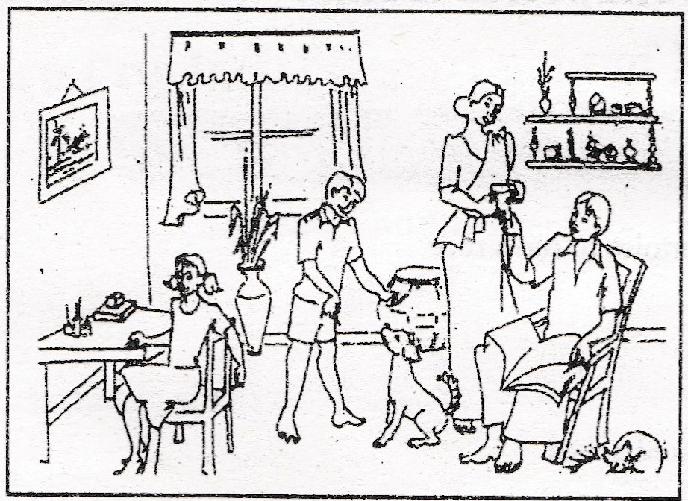

………………………………………………………………………………………………………………………………………………………………………………………………………………………………………………………………………………………………………………………………………………………………………………………………………………………………………………………………………………………………………………………………………………………………………………………………………………………………………………………………………………………………………………………………………………………………………………………………………………………………………………………………………………………………………………………………………………

13. Write an essay with a word count between 125-150 words. ***(10 Marks)***

* Importance of protecting nature for future generations
* How politeness influence others
* A visit to a place of historical importance.